|  |  |  |  |  |  |
| --- | --- | --- | --- | --- | --- |
| Date | 8-Sep-22 | | | Tester Name | Mohammad Yusuf |
| Environment | Penfax - Test | | | Login used |  |
| Operating System | Select OS | Version: | Update: | | |
| Software Used | Select Software | Version: | Update: | | |
| Select Software | Version: | Update: | | |
| Release version |  | | | | |
| Title | M17 Contributions & DCT | | | | |
| Test Type | Regression | | | | |
| Test Scenario | M17.18 Printing a File Summary for Contribution Files | | | | |
|  |  | | | | |
| Expected Results | Print button under File Details should open a File Summary in PDF format and user should be able to print that PDF. | | | | |
| Pass/Fail | Pass | | | JIRA# | N/A |

Describe your steps with screenshots:

1. Log into MEPP DCT and select the Employer from the dropdown.

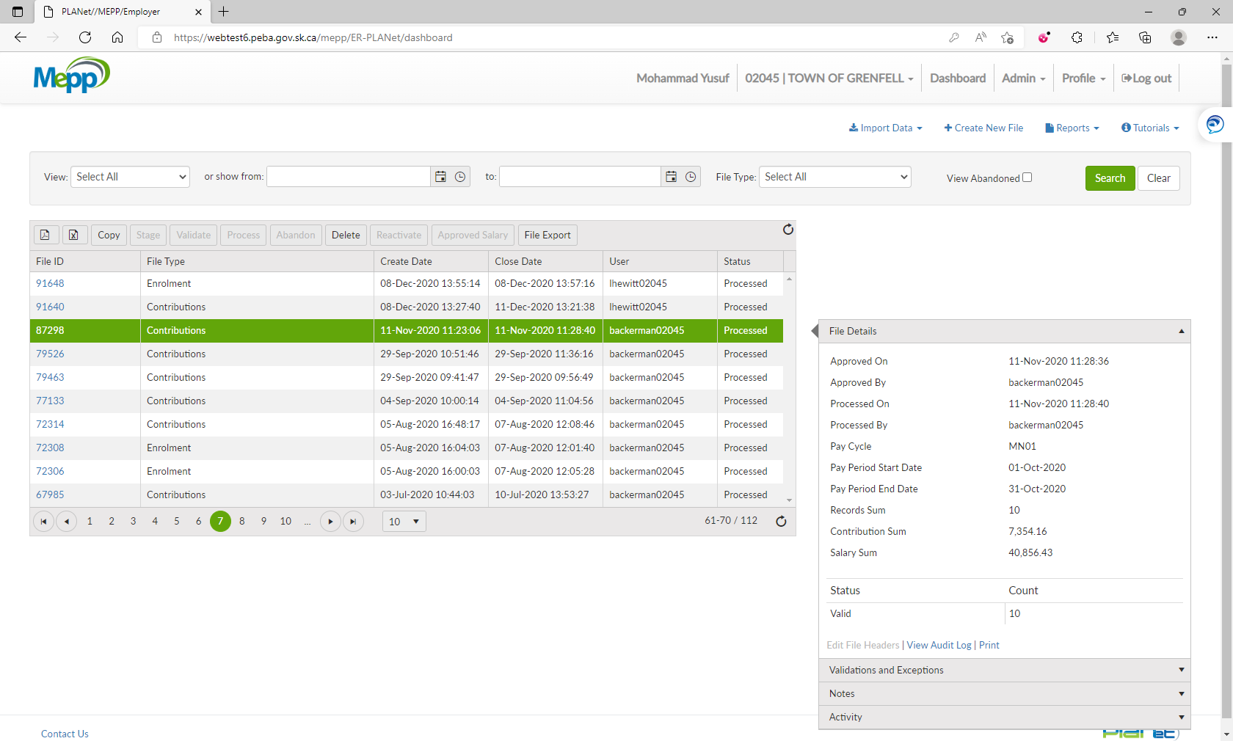

1. Click on any Contribution file ID. Under File Details, click on Print.

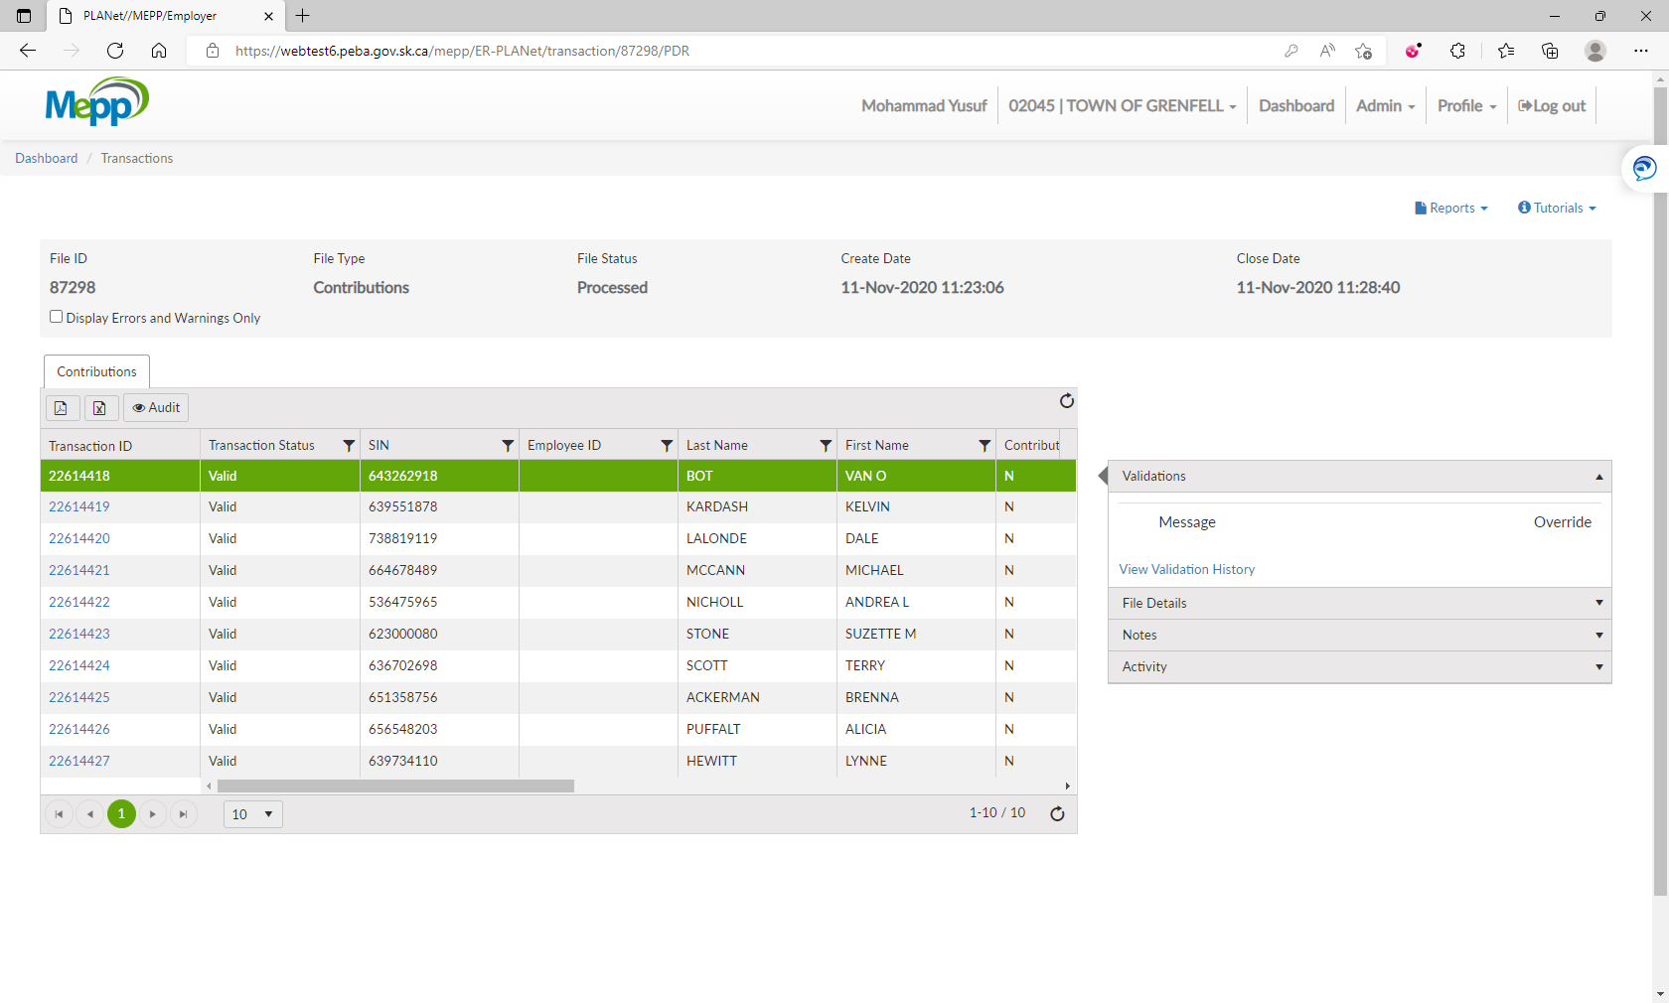

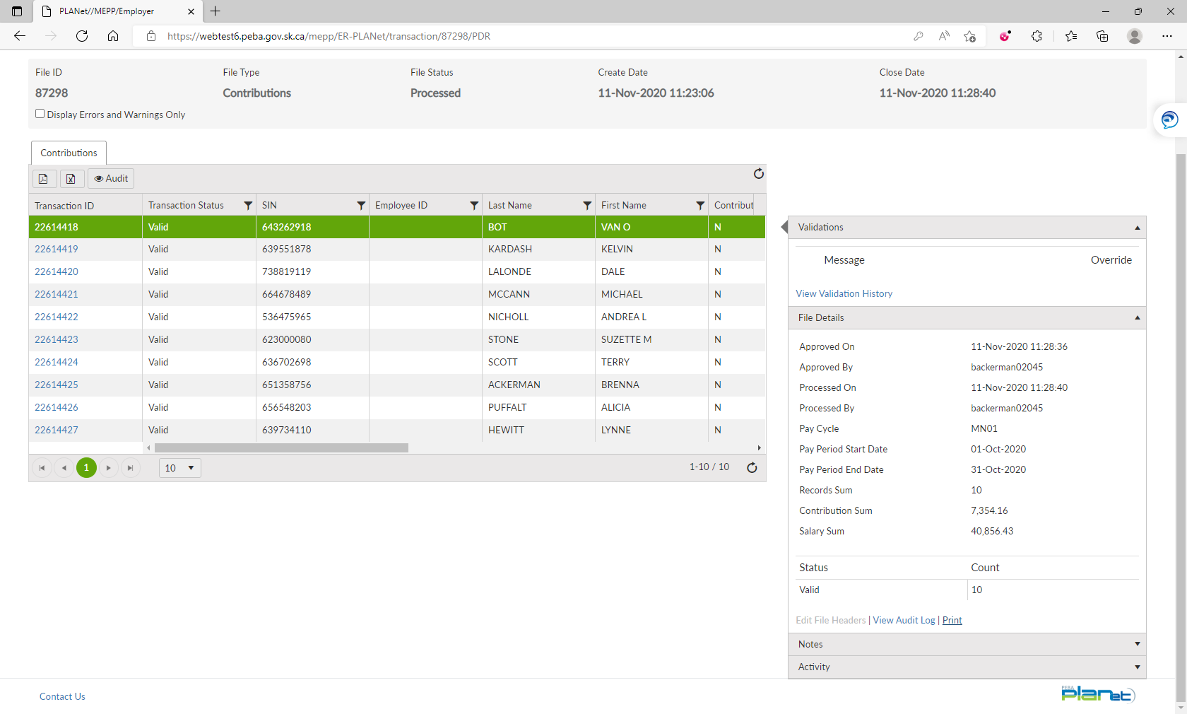

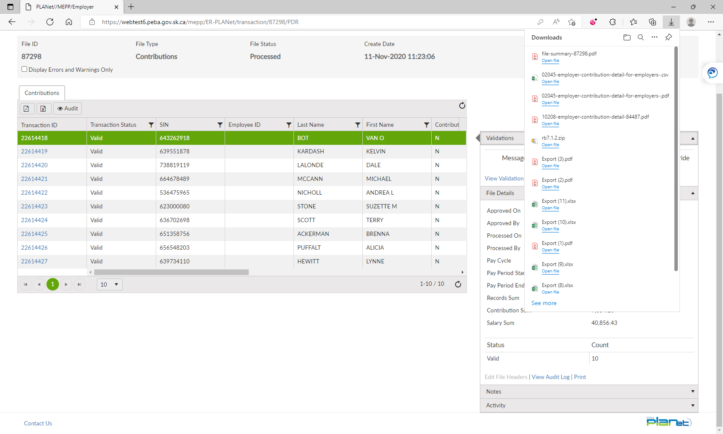

1. That will open a File Summary in PDF format. Click on Print icon.

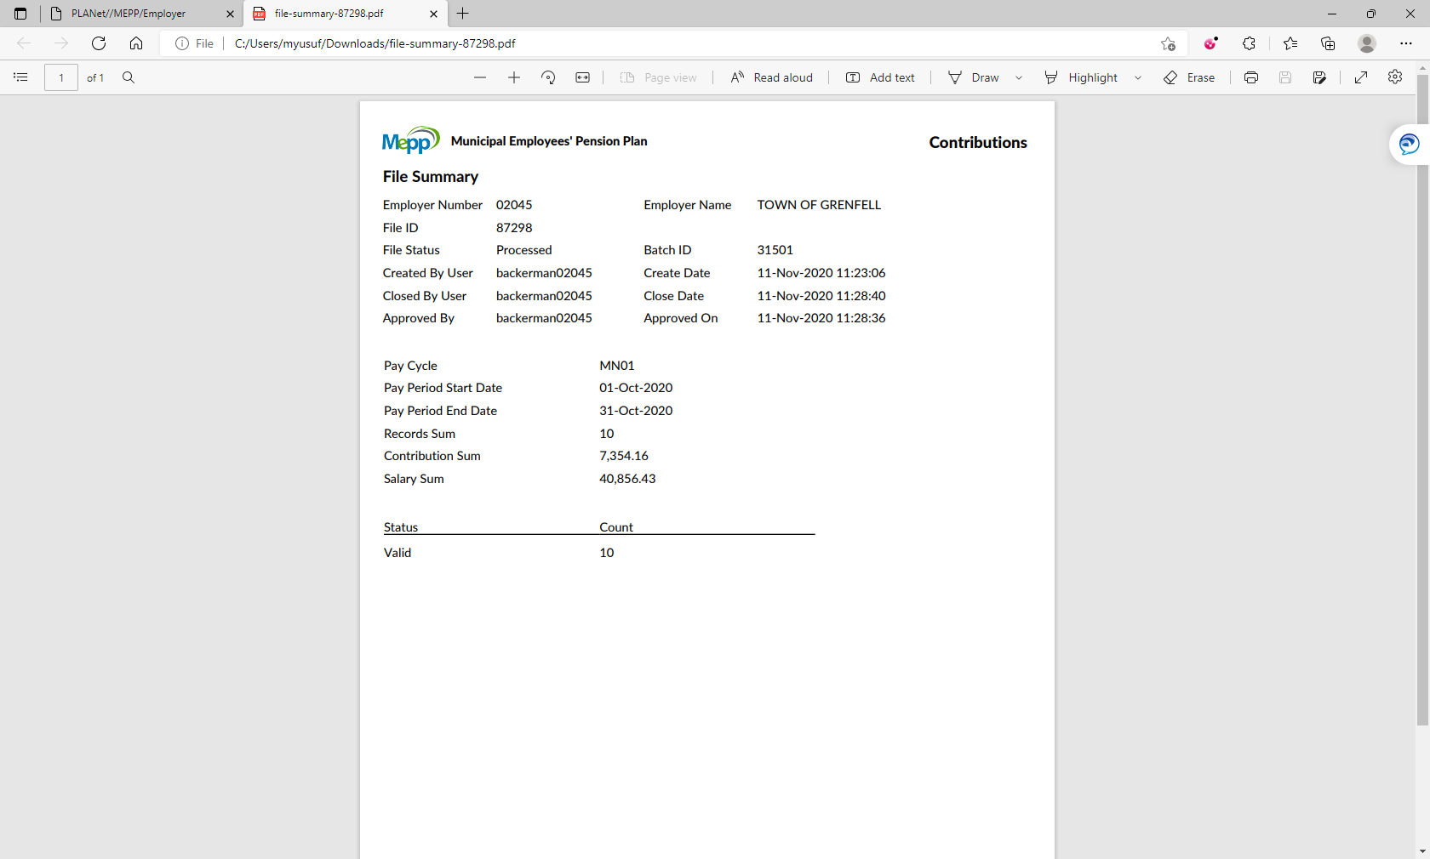

1. Set your preferences and print that.